**Global Vaccine Action Plan**

*Secretariat Annual Report 2016*

*Priority Country report on progress towards*

*GVAP-RVAP goals*

**NIGERIA**

1. **Progress towards achievement of GVAP goals**
2. **Summary**

The summary table below describes the current situation in Nigeria regarding achieving the GVAP goals. Data used to assess progress towards achievement of GVAP goals are included in the annex.

| **Area** | **Indicator** | **Nigeria** |
| --- | --- | --- |
| **5. Reach 90% national coverage and 80% in every district with 3 doses of DTP-containing vaccine** | **National coverage (2015 WUENIC)** | **56%** |
| **Drop-out rate DTP1 to DTP3 (2015 WUENIC)** | **20%** |
| **Actual numbers of children that dropped out (2015 WUENIC)** | **927,146** |
| **Difference between poorest and richest quintile DTP3 coverage (2013 DHS)** | **64.7 percentage point** |
| **Reported percent of districts with ≥80% coverage (from 2015 JRF)** | **80%** |

**3.3. Goal 3: Meet vaccination coverage targets**

1. **Achieve 90% national coverage and 80% coverage in every district with three doses of diphtheria-tetanus-pertussis containing vaccines**

The WHO-UNICEF estimated coverage rate for the third dose of DPT-containing vaccine (pentavalent) in 2015, which was recently revised downward following the 2015 NNHS, was 56% among children 12-23 months of age, with a dropout rate between the first and third doses of 20% (from 70% to 56%). According to the 2015 NHHS, five of the country’s 37 states (14%) reached the target of at least 80% coverage for DPT3, 15 states (40%) achieved coverage rates of between 50% and 75%, and 16 states (43%) had coverage of less than 50%. As with measles vaccination, the range of DPT3 coverage by state is enormous – from 4.4% in Sokoto state to 91% in the Southeastern state of Imo (see Figure 2 above). There are also vast inequities in rates by rural vs. urban location and by household wealth. According to the 2013 DHS, DPT3 coverage in rural areas was only 40% of that of urban areas (25% vs. 62%) and thee was an eleven-fold increase in rates from the lowest wealth quintile (7%) to the highest (79.5%).[1] The NNHS also found that 21% of 12-23 month olds had not received a single vaccination. A more in-depth equity assessment will be conducted as a condition of Nigeria applying for GAVI support for rotavirus vaccine introduction (currently planned for 2018), along with preparation of a plan to address this problem.

Nigeria has also not been able to meet these targets for other vaccines in the immunization schedule – with national coverage for measles, three doses of polio and yellow fever vaccines all at 54-55%, and BCG at the highest at 68%, according to the revised WHO-UNICEF estimates. Unimmunized children in Nigeria account for one in three of all unimmunized children in Sub-Saharan Africa and for one in six of all of those in GAVI-supported countries.[2]

The country has made progress, however, with immunization coverage rates over the past five years, especially in the past two years. According to the WUENIC estimates, BCG coverage climbed 11 percentage points from 2011 to 2015 (from 57% to 68%), DPT 3 coverage rose eight percentage points (from 48% in 2011 to 56% in 2015), yellow fever vaccine coverage increased by 16 points – from 38% to 54% (a 42% increase), and measles by five points (from 49% to 54%). Among the reasons given by informants for these gains are increased population awareness of and thus demand for vaccination as a result of the recent introduction of pentavalent vaccine and on-going introduction of PCV and accompanying communications and social mobilization activities, greater involvement of traditional and political leaders in informing the public about vaccination, and the improved regularity of the vaccine supply, especially at the national level (as there has not been a national vaccine stockout since 2013).

The most prominent factors contributing to the country’s low immunization coverage rates are the following:

* **The shortage of health personnel in the public sector**. As mentioned in Section 2.3 above, there are insufficient numbers of frontline health workers in many areas in Nigeria, due to high attrition and transfer rates and the difficulty of recruiting workers for remote, rural areas. The frequent health worker strikes in recent years in several states have exacerbated the problem, making immunization and other health services unavailable for months at a time in these areas and increasing the pool of unimmunized children. With the continued poor economy in the country, more states are facing severe financing problems, resulting in non-payment of health workers’ salaries – a major reason for the strikes.
* **Lack of security in several parts of the country**. The Boko Haram insurgency that has been going on for several years – causing tens of thousands of people to flee to IDP camps and more secure areas – has made it difficult to provide immunization and other health services in parts of the North. There have also been multiple attempts – some successful – to attack health workers engaged in immunization. It is not surprising that the recently found cases of wild polio virus were in Borno State, where Boko Haram has its headquarters and where immunization coverage rates are low (28% for measles and 32% for DPT3, according to the 2015 NNHS). At the same time, the Niger Delta has experienced a series of bombings and kidnappings to “Delta avengers”, militants who are rebelling against the Government’s decision to end “amnesty fee” payments to communities damaged by oil drilling and production. These security problems limit the free movement of the population to seek services and of health workers to provide outreach and mobile services, as well as the Government’s ability to recruit health workers to these areas.
* **Uneven availability of immunization services**. There are around 25,000 PHC facilities in the country, including more than 1,150 health centers and 228 maternities recently built as part of the Government’s plan to increase the accessibility of PHC services to all communities throughout the country. According to the cMYP, most states and LGAs follow the “1-2-3 strategy”, which entails at least one immunization session at the facility per week, two outreaches per month, and three supportive supervision visits per month. However, many health facilities have trouble adhering to this strategy, due to a lack of personnel, a lack of transportation for outreaches or to collect vaccines from the LGA stores (in health centers without functioning cold chain equipment), and a general lack of funds for operational expenses. Those with functioning refrigerators are more likely to conduct immunization sessions on a weekly or more frequent basis.
* **Insufficient communications and social mobilization activities for routine immunization services and inadequate community participation**. Nigeria has a structure for promoting immunization and other health services through social mobilization committees in each LGA, guided by the National Social Mobilization Working Group of the ICC. There is also a network of around 10,000 volunteer community mobilizers, supported with polio funding, who help with social mobilization for SIAs, track pregnancies, refer parents for routine immunization and so forth through home visits. These efforts have reportedly been important for polio and other SIAs, but are less focused on routine immunization. In many areas in the North, there has been a low demand for and lack of trust in immunization and other health services, including past resistance to polio vaccination.

To address this problem and increase demand, the country, with HSS and ISS funding, established and trained more than 700 ward or village development committees (WCDs/VCDs) in 13 states in 2010 to promote health services in the community and build transparency and accountability into the management of PHC activities. The WDCs are involved in planning community-based health activities, educating the community about health, including immunization, tracking immunization defaulters, and co-managing the health facilities. A study found that the increase in DPT3 coverage rates was significantly greater in wards with GAVI-supported WCDs than in those without.[3] However, this is a partner-driven activity and the 2015 Joint Appraisal report found that only around 40% of the targeted wards had established WDCs and 20% of these were not functional. Many also lacked a sense of community ownership and were not very engaged with the health facilities. Since then, many more are likely to be inactive, because of the suspension of GAVI HSS funds since 2014.

* **Lack of funds for routine immunization and Reach Every Ward (REW) activities at the local level.** Nigeria has a national policy of Reach Every Ward and there has been a series of trainings on this strategy, using GAVI HSS and ISS funds. This has led to all LGAs developing microplans and improving other aspects of planning (e.g., vaccine forecasting, supervision plans). However, the lack of operational funds at the local level has affected the ability of many LGAs and health facilities to implement key components of REW, especially communications, activities to involve the community in planning, supportive supervision, and monitoring for action. According to the 2015 Joint Appraisal report, LGAs also often lack funding for essential operational expenses for routine immunization, such as cold chain maintenance and fuel costs, and transport for vaccine deliveries, outreach activities and supervision visits. This is due to inadequate budgets at the state and LGA levels for such routine expenses, as well as the slow release of GAVI ISS funds available to the states. In the combined post introduction evaluation (PIE) report for the introductions of PCV and IPV, 85% of health facilities reported having had a supportive supervision visit in the previous six months. However, the majority of these visits were conducted not by government officials, but by partners.[4]

The lack of funds at the local level may at least partially explain the finding during pentavalent vaccine PIE that 8-55% of mothers interviewed in six out of the first 14 states to introduce the vaccine reported having to pay for the immunizations their children received that day.[5] A summary of the impact of limited funds for operational expenses at the local level is shown in Figure 3.

Figure 3: Summary of the impact of limited funds for immunization operational expenses

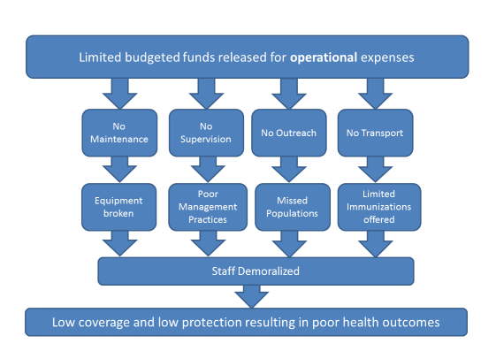

Source: Pentavalent PIE presentation, March 2013.

* **Poor quality of immunization data**. Administrative coverage data show immunization rates of more than 80% for all vaccines in most locations, while data from multiple surveys conducted in recent years (SMART, DHS, NNHS) consistently provide estimates of 20 or 30 percentage points lower. A key reason is inaccurate denominators used for administrative data. The PCV/IPV PIE found most health facilities using unrealistically low estimates for the target population. Different population data are often used for routine immunization and vaccine campaigns for the same population, making planning and reporting difficult.[6] The study also found that knowledge among health workers on how to calculate immunization coverage and dropout rates was almost universally poor, resulting in negative dropout rates at some health facilities the assessment team visited. This lack of knowledge, coupled with inadequate data management, make it difficult for program managers to monitor program performance and for health workers at the frontlines to use data for action. Data quality issues could therefore be a major contributor to the continual high dropout rates in Nigeria.

**ANNEXES**

Table 2: Reported DTPCV doses administered & coverage, Nigeria, 2000-2015

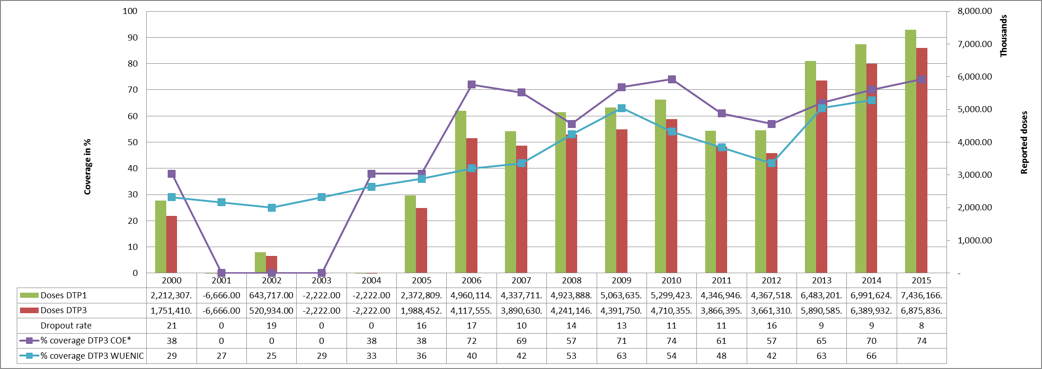

* COE: country Official Estimates

Source: WHO/IVB database, data reported to WHO by member states as of 1 July 2016

Figure 5: Percentage of district achieving <50%; 50-79% and ≥80% coverage, 2000-2015

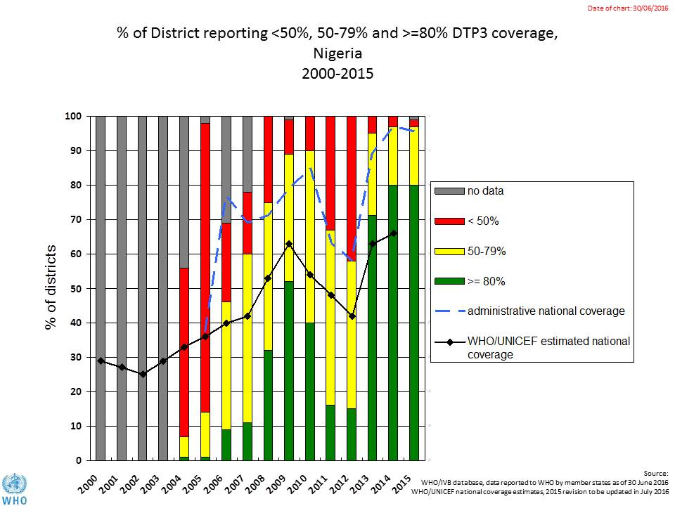

Figure 6: map with DTP3 coverage by district/province 2010 and 2015 (administrative data)

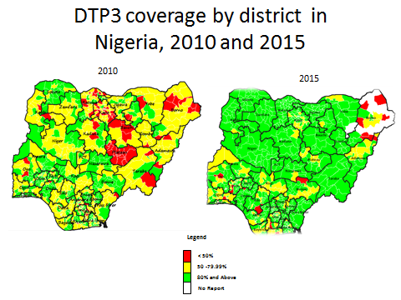

Figure 7: Immunization coverage data disaggregated by sex and wealth quintile

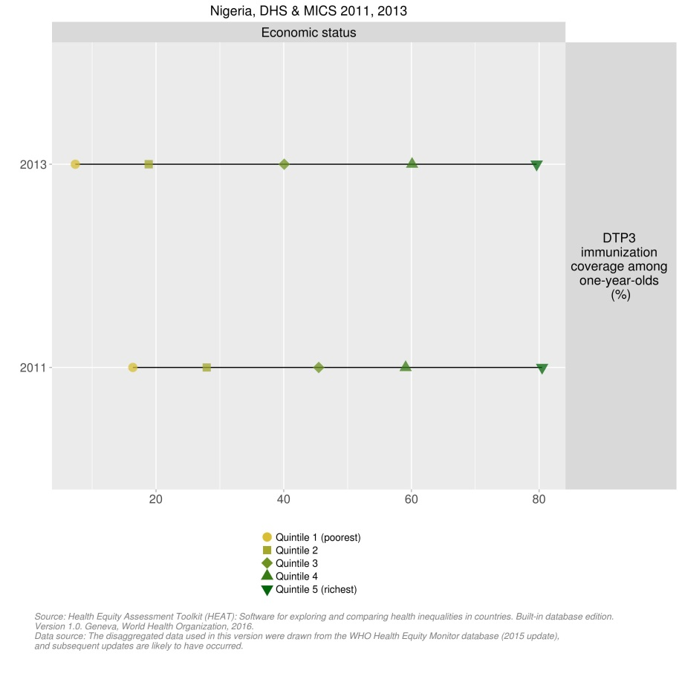

1. 2013 DHS.
2. Internal WHO briefing note for the 2016 joint appraisal.
3. cMYP.
4. Report on the Post-Introduction Evaluation of Pneumococcal Conjugate Vaccine (PCV10) and Inactivated Polio Vaccine (IPV) in Phase 1 States in Nigeria, March 2016.
5. Presentation of Post-introduction evaluation (PIE) of pentavalent vaccine introduction in Nigeria Phase I states, March 2013.
6. cMYP.